Your Paper's Title Starts Here: Use Times new roman 18 pt
(Use the Microsoft Word template style: “ams heading of papers”)

Firstname LASTNAME First Author¹*, Firstname LASTNAME Second Author² and Firstname LASTNAME Last Author³
(Use the Microsoft Word template style: “ams author”) 12 pt, * please mark the corresponding author with an asterisk

Authors’ affiliations and addresses:  ¹ Full address of the first author, including country  e-mail:  ² Full address of the second author, including country  e-mail:  ³ Full address of the last author, including country  e-mail:  *Correspondence:  Firstname Lastname, Full address of the corresponding author, including country  tel.:  e-mail:  Funding information:  Funding Agency  Grant Number  Acknowledgement:  How to cite this article:  DOI:  https://doi.org/10.46544/AMS.v30iX.X |  | Abstract  The abstract should contain a concise description of the contents and main results of the manuscript. It should be about 250 words (approx. 30 rows).  10 pt (Use the Microsoft Word template style: “ams abstract and keywords”)  Keywords  List the keywords covered in your paper. These keywords will also be used by the publisher to produce a keyword index.  10 pt (Use the Microsoft Word template style: “ams abstract and keywords”)
 | © 2025 by the authors. Submitted for possible open access publication under the terms and conditions of the Creative Commons Attribution (CC BY) license (http://creativecommons.org/licenses/by/4.0/).
Introduction 10 pt
(Use the Microsoft Word template style: “ams heading of section”)

All manuscripts must be prepared in English (either British or American English can be used, but be consistent within the manuscript), together with tables and figures inserted into the text, otherwise we cannot publish your paper.

Journal prefers scientific papers subdivided into the following sections:
Title
Authors and affiliation
Acknowledgments
Abstract
Introduction
Material and Methods
Results
Discussion
Conclusions
References.

Please keep the second copy of your manuscript in your office. When receiving the paper, we assume that the corresponding authors grant us the copyright to use the paper for the book or journal in question. Should authors use tables or figures from other Publications, they must ask the corresponding publishers to grant them the right to publish this material in their paper.
(Use the Microsoft Word template style: “ams text”)

Organization of the Text
(Use the Microsoft Word template style: “ams heading of subsection“)

Section Headings. The section headings are in boldface capital and lowercase letters. Second level headings are typed as part of the succeeding paragraph (like the subsection heading of this paragraph).

Page Numbers. Do not number your paper.

Tables 8 pt. (Use the Microsoft Word template style: “ams figure and table caption”)

Tab. 1. Recovery rates of MSWI residue samples after separation using a cyclosizer
Particle size range [µm] |  | APC 1 | APC 2 | FA 3 | APC 1 | APC 2 | FA 3
APC 1 & APC 2 | FA 3 | [g] | [g] | [g] | [%] | [%] | [%]
49-100 | 55 – 100 | 4.1 | 6.5 | 4.6 | 5.1 | 8.1 | 5.7
34-49 | 39 – 55 | 6.5 | 9.0 | 8.8 | 8.2 | 11.3 | 11.0
23-34 | 26 – 39 | 11.0 | 12.7 | 13.9 | 13.7 | 15.9 | 17.4
16-23 | 19 – 26 | 9.0 | 9.1 | 11.1 | 11.2 | 11.3 | 13.9
12-16 | 14 – 19 | 5.7 | 5.2 | 7.3 | 7.2 | 6.6 | 9.1
< 12 | < 14 | 19.7 | 22.2 | 31.2 | 24.6 | 27.8 | 39.0
Dissolved solids |  | 24.0 | 15.2 | 3.2 | 30.0 | 19.0 | 4.0
Sum |  | 80 | 80 | 80 | 100 | 100 | 100

Tables (refer with: Tab. 1, Tab. 2, ...) should be presented as part of the text, but in such a way as to avoid confusion with the text. A descriptive title should be placed above each table. Units in tables should be given in square brackets [meV].

Special Signs. for example, α γ μ Ω () ≥ ± ● Γ {110} should always be written in with the fonts Times New Roman or Arial, especially in the figures and tables.

SI Units. (International System of Units) should be used for this journal. Imperial, US customary and other units should be converted to SI units whenever possible before submission of a manuscript to the journal.

Macros. Do not use any macros for the figures and tables. (We will not be able to convert such papers into our system).

Language. All text, figures and tables must be in English.

Figures. (Use the Microsoft Word template style: “ams figure and table caption”)
Figures, photographs, maps and schemes in your manuscript should be inserted directly in the appropriate place in the text.
If some/all figures are too large, you can save and submit your original figures, photographs, maps, large schemes as separate graphics files (JPG graphics format is preferred). However, there still should be a reference to the particular figure in the appropriate place in the text.
Black-and-white photographs should be sharp and contrast and their reduction minimally to one half of original size can be desirable.
A reference to each illustration should be made in the text. Each illustration should be identified by its number and the name(s) of the author(s) or its corresponding reference source.
Captions of the illustrations should be written using font Times New Roman, size 8 pt, in italics.
Colour illustrations are acceptable since the journal provides online access to articles. However, try printing your article in grayscale to verify that the readers will not miss the information from your illustrations if they have only monochrome printers.

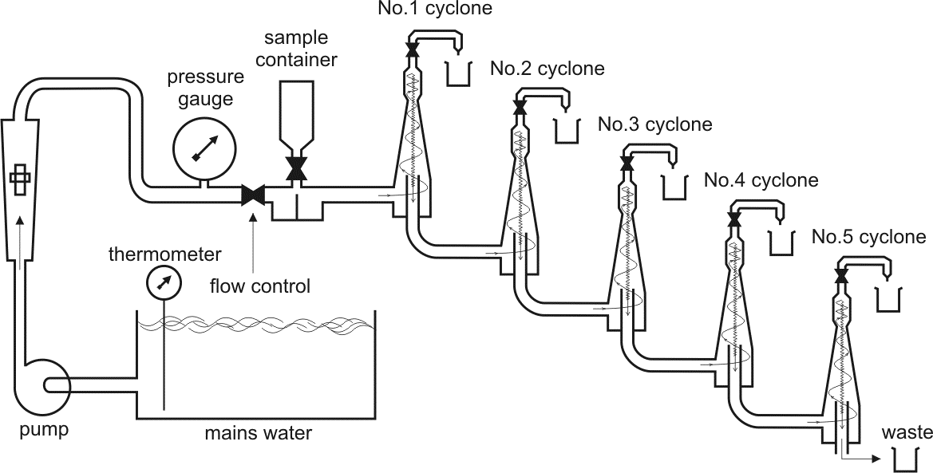
Fig. 1. The diagrammatic arrangement of the cyclosizer device

Equations. Equations (refer with: Eq. 1, Eq. 2, ...) 10 pt. The Microsoft Equation Editor or the MathType add-on in your manuscript should be used to insert equations and/or corresponding symbols into the text. Equations should be editable by the editorial office and not appear in a picture format. (Use the Microsoft Word template style: “ams equation”)
There should be one line of space above the equation and one line of space below it before the text continues. The equations have to be numbered sequentially, and the number put in parentheses at the right-hand edge of the text. Equations should be punctuated as if they were an ordinary part of the text. Punctuation appears after the equation but before the equation number.

c² = a² + b². (1)

Summary
If you follow the “checklist” your paper will conform to the requirements of the publisher and facilitate a problem-free publication process.

References
Only the author-date system of references style (Harvard or APA style) is acceptable. References should be listed alphabetically. In the reference list, names of all authors should be given. Do NOT use "et al." in the list of references!
If the authors are not sure how to properly create the list of references using Harvard or APA referencing style, they can use one of many online services (http://www.citethisforme.com, http://www.citationmachine.net/, etc.).
We recommend preparing the references with a bibliography software package, such as EndNote, ReferenceManager or Zotero to avoid typing mistakes and duplicated references.
Include the digital object identifier (DOI) for all references where available.
References should have a range of at least 20-30 positions, covering important previous works realised in the given area of interest on an international scale. References covered by major citation databases are preferred (Scopus, Web of Science).
(Use the Microsoft Word template style: “ams refer”)

References

Harvard referencing style
Pickett, S. and McDonnell, M. (2017). The art and science of writing a publishable article. Journal of Urban Ecology, 3(1).
In-text reference: (Pickett and McDonnell, 2017)

APA (6th edition) referencing style
Pickett, S., & McDonnell, M. (2017). The art and science of writing a publishable article. Journal Of Urban Ecology, 3(1). http://dx.doi.org/10.1093/jue/jux018
In-text reference: (Pickett & McDonnell, 2017)

